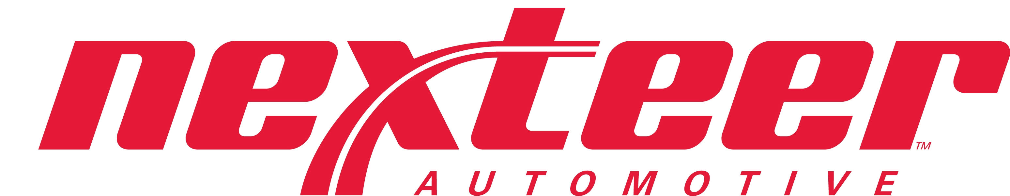 INTERIM RECOVERY WORKSHEET
Supplier | SUPPLIER NAME: |  |  |  |  |  |  |  |  |  |  | PART NAME:
Supplier | DUNS CODE: |  |  |  |  |  |  |  |  |  |  | PART #:
Supplier | RESUBMISSION DATE:
Supplier | INTERIM EXPIRE DATE: |  |  |  |  |  |  |  |  |  |  | CN#:
Supplier | APPLICATION: |  |  |  |  |  |  |  |  |  |  | ECL: |  |  |  |  |  | DATE:
Supplier | Submission Level: |  |  | KG Wt:
Supplier | INTERIM CLASS: |  | Approved:__________ Reject: _______________________  (Must have Engineering Permit Approved for part print deviations)
 | BRIEF REASON:
Supplier | ISSUE: (List DIM, APP, LAB, Process, Tooling, Capacity or Start-up issues) |  |  |  |  |  |  |  | ACTION PLAN: |  |  |  |  |  |  |  |  |  |  |  |  | COMPLETION DATE:
Supplier | WHERE APPLICABLE, ARE INTERIM ISSUES ADDRESSED ON THE EARLY PRODUCTION PRE-LAUNCH CONTROL PLAN? (e.g. 100% inspection, rework, temporary operations) Please explain below.
Supplier | SUPPLIER (Authorized signature): |  |  |  |  |  |  |  |  |  |  |  |  |  | Phone:
Supplier | NAME & TITLE (Print) |  |  |  |  |  |  |  |  |  |  |  |  |  | FAX:
Supplier | Part submission warrant MUST BE INCLUDED with customer approvals in order to process your request and send to the purchasing Region
Nexteer | CUSTOMER COMMENTS:
Nexteer | APPROVALS: |  |  |  |  | SIGNATURE |  |  |  |  | NAME (Print) |  |  |  |  |  |  |  |  |  |  |  | Date
Nexteer | AQE / SQE
Nexteer | PLANT PPAP COORDINATOR
Nexteer | PRODUCT ENGINEER (DRE): (Design Responsible Engineer)
Nexteer | *LAB/MATERIAL ENGINEER:
Nexteer | *APPEARANCE/PAINT ENGINEER:
Nexteer | *OTHER PLANT PERSONNEL (Quality or Mfg. Engineer)
Nexteer | *OTHER
Nexteer | * Approval Optional

Instructions for completing Nexteer Automotive SQ Interim PPAP Worksheet.

(Note: Nexteer Automotive Regions may request suppliers to utilize a different interim PPAP form such as an AIAG PPAP 4th Edition form or a Regional or customer specific form.)

Field | Instructions
Adding a row to this form | If you need to add a line to this form, on the Forms toolbar at the top, uncheck the lock button, add a line(s) and then click on the lock button again to lock the form. The lock button must be on in order for the form to work properly.
Supplier Name | Name assigned to manufacturing location.
Duns Code | Supplier assigned DUNS number of the manufacturing location.
Resubmission Date | New promise date or PPAP submission date. The supplier’s commitment date to have the Corrective Action Plan item(s) completed and resubmitted to the PPAP group. Part Readiness tracks the re-submission date for follow-up when required. The re-submission date must be prior to the interim expiration date.
Interim Expire Date | The expiration date is the last acceptable date of shipment of the part under the Interim Approval status report.
Application | List programs where the part number is used.
Part Name | Engineering released finished end item name.
Part Number | Part Number submitted for PPAP.
CN # | Change Number.
ECL | Engineering Change Level of the associated PPAP submission.
CN Date | Date of the Change Number.
Submission Level | Submission Level 1-5. Enter submission level determined by the procuring Region.
KG/Wt. | Enter the actual weight in kilograms to four decimal places.
Brief Reason | Provide a brief reason for requesting an interim approval. Where applicable, specify if tooling modifications or other modifications were made.
Issues/Action Plan | List all issues applicable, and used additional sheets if necessary. For non-grained parts, submit on Less Finish part number. For color/gloss issues, submit on color part number. Provide a corrective action plan with date of completion, when requesting for approval.
Date | Target date for completion.
Supplier | Required supplier authorized signature from responsible supplier official to ensure compliance to the information provided for Interim approval. Legibly print or type name, title and include phone and fax number.
Customer Comments | Nexteer Automotive to complete.
Approvals | Obtain appropriate signatures for areas of concern. Suppliers must have SQE’s or Plant designated PPAP representative’s approval. The DRE signature is required in any situation where the part does not meet the print requirements. Requirements are subjected to change and may vary for each procuring Region.
* Approval Optional | Items marked with * are optional.

